|  |
| --- |
| 2016 UAV Challenge |
| Deliverable 2: Technical Report |
| 2014 UAV Outback Challenge – Search and Rescue Challenge |

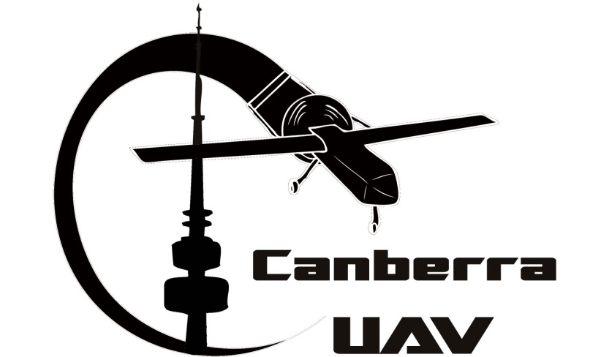

|  |
| --- |
| www.canberraUAV.org.au |

# Table of Contents

1 Table of Contents 2

2 Statement of Originality and Accuracy 3

3 Compliance Statement 4

4 Executive Summary 7

5 Introduction and Design Approach 8

6 Landing Site Analysis Strategy 9

6.1 Finding Joe 9

6.2 Finding a Suitable Landing Site 9

7 System Design 10

7.1 System Diagram 10

7.2 Aeronautical Requirements 10

7.3 Control and Termination System Design 12

7.4 Flight Termination Method Analysis 12

7.5 Geofence system design 13

7.6 Radio Equipment 13

8 Risk Assessment 14

8.1 General Risk Assessment 14

8.2 Risks Associated With Autonomous Takeoff and Landing 15

9 Risk Management 17

9.1 Flight Termination 17

9.2 Loss of data link 17

9.3 Engine Failure 18

9.4 Loss of GPS Position 18

9.5 Autopilot lock-up 18

9.6 Failure of Ground Control Station 18

9.7 Li-Po Battery and Fuel Management 19

9.8 Other risks identified in risk management section 19

10 Flight Test Results and Discussion 20

10.1 Project Status 20

10.2 Results 20

11 Conclusions 22

# Statement of Originality and Accuracy

*We declare that this report is entirely the work of the team members listed below, and has not previously been submitted by us, or others for this challenge or any other similar event.*

*We have acknowledged external material with appropriate references, quotes or notes to indicate its source.*

*We declare that this report is an accurate record of activities carried out by us in preparing for this specific challenge. The events, data and other material contained within this report actually occurred and have been fully detailed.*

Peter Barker

Darrell Burkey

Stephen Dade (team manager)

Justin Galbraith

Chris Gough

Grant Morphett

Greg Oakes

James Pattison

Jack Pittar

Ryan Pope

Matthew Ridley

Andrew Tridgell

Paul Tridgell

Paul Williamson

# Compliance Statement

Team Name: **CanberraUAV**

We declare that this report and the entry that it describes complies with the rules of the 2016 UAV Challenge, and that we enter with the intention of competing in the spirit of the challenge. Specifically we declare that our entry is compliant with the following topics and provide reference to within our Deliverable 2 document where our method of compliance is described:

| **Rules Reference** | **Topic** | **Compliance** | **Deliverable 2 Reference** |
| --- | --- | --- | --- |
| **Mandatory / Essential**  *Non-compliance in this section will result in a No-Go finding unless there are significant and/or extenuating circumstances. Please read the rules in detail. If using two aircraft ensure both aircraft are considered and Deliverable 2 references are provided for both aircraft if necessary.* | | | |
| 1.6 | Maximum of two aircraft for the mission | 🗹 Compliant | 7.2.1 |
| 3.1.1 | Must not be a commercial off-the-shelf complete system | 🗹 Retrieval aircraft Compliant  🗹 Support aircraft Compliant | 7.1 |
| 3.1.1 | Must be capable of autonomous flight | 🗹 Retrieval aircraft Compliant  🗹 Support aircraft Compliant | 7.1 |
| 3.1.1 | Must have a maximum gross weight of less than 100 kg (rotary) or 150kg (fixed wing) | 🗹 Retrieval aircraft Compliant  🗹 Support aircraft Compliant | 7.2.1 |
| 3.1.1 | Must have continuous telemetry radio communication with the UAV Controller | 🗹 Retrieval aircraft Compliant  🗹 Support aircraft Compliant | 7.6 |
| 3.1.1 | Must have an easily accessible E-Stop to render the aircraft deactivated | 🗹 Retrieval aircraft Compliant  🗹 Support aircraft Compliant | 7.2.3 |
| 3.1.1 | Must have an external visual indication of state (armed, inert, disarmed) | 🗹 Retrieval aircraft Compliant  🗹 Support aircraft Compliant | 7.2.3 |
| 3.1.1 | Must have an arming switch | 🗹 Retrieval aircraft Compliant | 7.2.3 |
| 3.1.3 | Must implement automatic (on-board) detection of crossing a Geofence boundary | 🗹 Retrieval aircraft Compliant  🗹 Support aircraft Compliant | 7.5 |
| 3.1.4 | Must include a flight termination system meeting all conditions | 🗹 Retrieval aircraft Compliant  🗹 Support aircraft Compliant | 7.3 |
| 3.1.5 & 5.3.2 | Flight termination method described and analysis provided of maximum distance outside Geofence | 🗹 Retrieval aircraft Compliant  🗹 Support aircraft Compliant | 7.4 |
| 3.1.6 | All criteria for flight termination must result in immediate activation of flight termination | 🗹 Retrieval aircraft Compliant  🗹 Support aircraft Compliant | 7.3 |
| 3.2.1 | Flight in the Transit Corridor and Remote Landing Site must be autonomous | 🗹 Retrieval aircraft Compliant  🗹 Support aircraft Compliant | 7.2.1 |
| 3.2.2 | Must have a ground control station that provides a graphical display | 🗹 Retrieval aircraft Compliant  🗹 Support aircraft Compliant | 7.2.2 |
| 3.2.2 | Must provide an NMEA data feed from the ground station | 🗹 Retrieval aircraft Compliant  🗹 Support aircraft Compliant | 7.2.2 |
| 3.2.3 | Communication equipment must comply with ACMA regulations | 🗹 Compliant | 7.6 |
| 3.3.2 & 5.3.2 | AMSL altitudes will be measured and reported as pressure altitudes | 🗹 Compliant | 7.2.2 |
| 3.3.3 & 5.3.2 | Correct aeronautical units used | 🗹 Compliant | N/A |
| 3.3.3 | Description of how aircraft will be maintained within its airspeed envelope | 🗹 Retrieval aircraft Compliant  🗹 Support aircraft Compliant | 7.2 |
| 3.4.5 | Pyrotechnic mechanisms have safety mechanism implemented and safety manual provided | □ Compliant  🗹 Not Applicable | N/A |
| 5.2 | Disclosure of sponsors and funding sources | 🗹 Compliant | 5 |
| 5.3.2 | Statement of originality and accuracy included | 🗹 Compliant | 2 |
| 5.3.2 | Executive summary provided | 🗹 Compliant | 4 |
| 5.3.2 | Introduction and design approach provided | 🗹 Compliant | 5 |
| 5.3.2 | Landing site analysis strategy provided | 🗹 Compliant | 6 |
| 5.3.2 | System Diagram provided | 🗹 Compliant | 7.1 |
| 5.3.2 | Flight termination system design, state machine diagrams and transitions provided | 🗹 Compliant | 7.3 |
| 5.3.2 | Geofence system design provided | 🗹 Compliant | 7.5 |
| 5.3.2 | Radio frequencies to be used and relevant licences provided | 🗹 Compliant | 7.6 |
| 5.3.2 | Updated risk assessment provided | 🗹 Compliant | 8.1 |
| 5.3.2 | Assessment of the risks associated with autonomously taking off and landing provided | 🗹 Compliant | 8.2 |
| 5.3.2 | Risk Management provided | 🗹 Compliant | 9 |
| 5.3.2 | Details of the system response to loss of data link provided | 🗹 Compliant | 9.2 |
| 5.3.2 | Details of the system response to loss of GPS provided | 🗹 Compliant | 9.4 |
| 5.3.2 | Details of the system response to lock-up or failure of autopilot provided | 🗹 Compliant | 9.5 |
| 5.3.2 | Details of the system response to lock-up or failure of the GCS provided | 🗹 Compliant | 9.6 |
| 5.3.2 | Details of the system response to loss of engine power provided | 🗹 Compliant | 9.3 |
| 5.3.2 | Details of fuel and/or battery management provided | 🗹 Compliant | 9.7 |
| 5.3.2 | Details of the management of other risks provided | 🗹 Compliant | 9.8 |
| 5.3.2 | Flight tests results provided | 🗹 Compliant | 10 |
| 5.3.2 | Conclusions provided | 🗹 Compliant | 11 |
| 5.3.2 | Video provided showing the retrieval aircraft autonomously landing and taking off | 🗹 Compliant | 4 |
| 5.3.2 | Video provided showing the teams pre-flight set up and checks | 🗹 Compliant | 4 |
| **Highly Desirable** | | | |
| 7.2 | “Soft Geofence” | 🗹 Implemented  □ Not Implemented | 7.5 |
| 5.3.2 | Deliverable 2: Max 23 pages. | 🗹 Compliant  □ Non-Compliant | N/A |

Additional Information:

Date: 09 April 2016

Signed by a team representative, on behalf of all team members:



Printed Name: Stephen Dade

# Executive Summary

CanberraUAV has been fortunate to attract team members from a wide variety of relevant disciplines, including aeromodelling, mechatronics, aerospace engineering, software engineering, communications engineering, and photography. Building on our experiences in the 2012 and 2014 Outback Challenges, we have continued development of flight controller software and hardware. With the new challenges presented in the 2016 Medical Express, we have further extended our capabilities by building additional functionality to operate with new and innovative airframes.

Our design approach is to maximise autonomy while ensuring safety to people and property. Our redundant hierarchical architecture provides a high degree of on-board processing and decision-making. The target tracking, automated take-off and landing, flight stabilisation, navigation, failsafe and communication to the ground station will be situated on-board the aircraft with the ground station providing the required overall monitoring and management functionality. A relay UAV with the same level of autonomy will provide an additional constant communications link between the retrieval UAV and ground station.

We are designing our system for completely automated “Joe localisation”, using a powerful on-board computer. The aim is for the retrieval UAV to not just be able to fly itself, but to also perform automated vertical take-offs and landings. On finding the target (and after confirmation from UAV Challenge organisers), the UAV will land in order to collect the blood sample, render itself safe to approach, then after the sample in in place and being armed, take off and return to the base. It will do all of this, while carefully monitoring all aspects of the mission to ensure that safety is maintained.

Results from our test flights to date have already demonstrated almost all of the above capabilities. With ongoing testing, we will be able to refine, debug and integrate our aircraft subsystems to provide a fully functioning UAV for both the retrieval and relay UAV roles.

As part of this Deliverable, we have submitted two airframes. The intention is to have one airframe act as the retrieval UAV and the other as the relay UAV; however both airframes are fully capable of performing either role. Our intention is to continue developing and testing both airframes in the lead-up to the UAV Challenge, with a final decision based on which airframe is most suitable for the weather conditions (particularly wind) during the event.

Unless specifically mentioned in the relevant section, this report is applicable to both airframes.

Where it is still applicable, parts of this document have been derived from CanberraUAV’s Deliverable 2 in the 2012 and 2014 Outback UAV Challenges.

Our videos accompanying this report (satisfying the video requirements in Section 5.3.2 of the rules) are at:

<https://youtu.be/PuOYfjvZW_Y?t=5m5s> for our helicopter airframe

<https://youtu.be/PuOYfjvZW_Y> for our multicopter fixed wing hybrid “quadplane” airframe

# Introduction and Design Approach

This report focuses on three major parts: Our design approach, risk management and flight test results.

Our design approach is based around satisfying the rules for the UAV Challenge as our first priority. As part of this, safety is a key feature. This is reflected in the redundancy designed into our systems, including multiple independent radio links, a backup suite of sensors and a failsafe system which will terminate the flight if required. In the spirit of the competition, we are designing our aircraft to be as automated as possible, including assisted Joe-detection via on-board image processing and automatic vertical take-off and landing.

Our risk management processes have evolved in the course of development and testing. Our extensive development process has provided us with a comprehensive set of pre-flight checks designed to detect errors before flight. Many hours of flight testing have yielded proven responses to various errors and failures that may be encountered whilst airborne, with an emphasis on safety to all people and property on the ground.

Our team has been flying a number of small and large test platforms over the 5 years, including many flights with UAV Challenge-capable airframes. These development, test and evaluation flights have generated a significant data set that has enabled us to iteratively refine our command and control systems both in terms of flight accuracy and reliability. At the time of writing, final testing is underway of our airframes and flight controllers. Systems integration of the imaging and final telemetry systems will soon follow, with ongoing testing to determine reliability and refine some functions where necessary.

CanberraUAV would like to thank the following organisations for donations of money, equipment or expertise:

* 3DRobotics
* The Ardupilot development community
* Canberra Model Aircraft Club (CMAC)
* Gaui Helicopters
* Halo Blades
* Hobbyking
* Monaro Models

# Landing Site Analysis Strategy

## Finding Joe

The localisation of Joe’s position will be performed via image recognition, using a similar system that was used in the 2014 OBC. Based on previous results from this system it is expected that the calculated position of Joe will be accurate to within 5m.

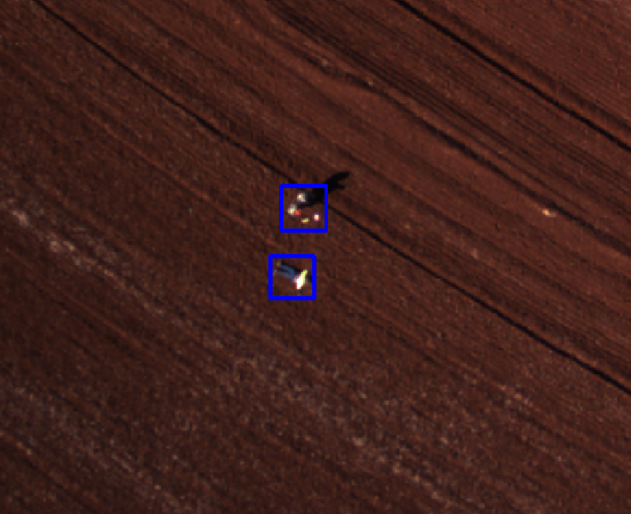

Figure 1: Example of Imaging System localisation of Joe's position

Our retrieval UAV will be equipped with a high sensitivity machine vision camera for high resolution still colour images (PtGrey Chameleon). It will take photos at a rate of approximately 1 Hz as the aircraft loiters or hovers over the approximate Joe coordinates provided by the UAV Challenge organisers. In order to negate the effects of vibration causing smearing to the images, the camera will be operated at a high shutter speed.

These images will be streamed to the on-board computer and storage, where they will be processed in near real-time. The images will be automatically analysed for distinctive features that may that may indicate a target of the shape and colour of a human has been found.

Images from the machine vision camera will also be downloaded to the ground station for further evaluation to allow for the possibility of manual Joe detection should the automatic system fail to detect Joe.

## Finding a Suitable Landing Site

A landing location will be determined by the personnel at the Ground Station, based on the returned images from the retrieval UAV.

The Ground Station software will draw a safe zone (30-50m radius circles around Joe’s position) to indicate available landing zones. The ground station personnel will then analyse this zone for any obstacles such as fences, trees, long grass or uneven ground.

Both airframes will be fitted with a robust undercarriage with a wide footprint to enable a safe landing in despite undulations in terrain or obstructions not shown in the aforementioned imagery.

# System Design

## System Diagram

The major drivers of our design approach were fivefold: safety, reliability, automation, portability, and open source. This is reflected in our radio system setup and design and failsafe systems. An overall breakdown of this system is shown below.

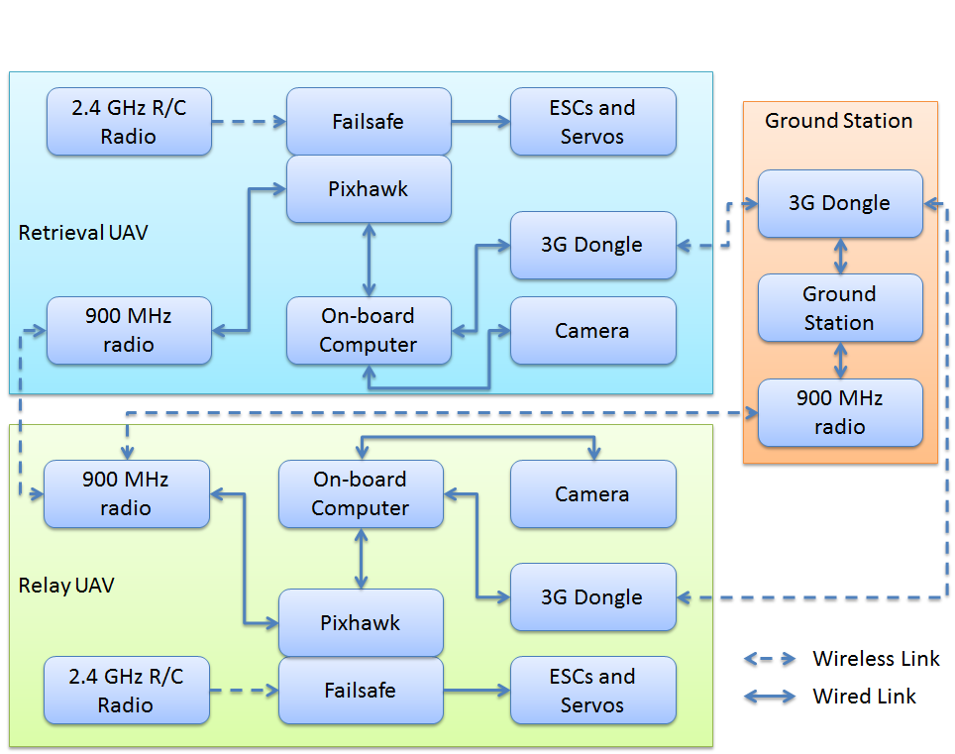

Figure 2 - Subsystem Layout of the retrieval UAV, relay UAV and Ground Station

The high level design consists of two UAVs, fitted with similar equipment. They would fly to Joe’s location via the transit corridor together. At the location, 1 UAV would hover or loiter nearby acting as a communications relay whilst the other UAV lands near Joe and obtains the blood sample. Both UAVs would then fly back to Base via the transit corridor.

Our team made the choice to use (and contribute back to) open source hardware and software (where available) for our UAV systems. We believe that our work should be available for all to use and further develop for the benefit of the whole search and rescue UAV community.

The specific set of hardware and software carried on-board the aircraft satisfies the UAV Challenge requirements of Type 2 Autonomy.

## Aeronautical Requirements

### Airframes

Our competition airframes will consist of a large RC helicopter and a hybrid multirotor/fixed-wing aircraft (a “quadplane”). Both will be able to fulfil the role of Retrieval or Relay UAV. A final decision as to which airframe will play each role will be decided based on further testing and evaluation and the weather conditions on the day at the competition.

Our helicopter airframe is a conventional large RC helicopter (Gaui GX9) powered by a four-stroke petrol engine. It has a maximum takeoff weight of less than 17kg.

Our quadplane airframe is based on the “Pilatus Porter”, a large scale model aircraft, with the addition of large vertical lift propellers mounted on the wings. It is powered by a two-stroke IC petrol engine for forward flight and with large electric motors for vertical flight. It has a maximum take-off weight of less than 16kg.

The stall speed of the quadplane airframe in fixed wing flight has been calculated to be below 28 kts. Both the helicopter and quadplane (in vertical flight mode), however, are able to hover at zero airspeed.

On the quadplane airframe in horizontal flight mode, the Pixhawk will ensure that the aircraft’s current airspeed is a sufficient margin above the stall speed in order to maintain adequate manoeuvrability throughout the flight. This will be achieved via the on-board sensors including the pitot tube based airspeed sensor, combined with the Total Energy Control System (TECS) in the flight software. This ensures the aircraft is able to control its speed and manoeuvrability on an energy (kinetic and potential) basis. The quadplane will automatically engage the vertical lift motors at airspeeds below 36 knots. This is a comfortable margin above the stall speed of 28 kts.

The cruise airspeed of both airframes is 56 kts.

Both airframes are using the Pixhawk autopilot platform running the APM software – an open source autopilot designed for autonomous vehicles. The advantage of using the APM software is that we can easily customise and debug the software to fit in with the requirements of the OBC, such as the geofencing requirement. The Pixhawk will feature dual GPS receivers and will be capable of carrying out the full mission (automated waypoint travel, automated takeoff and automated landing) in conjunction with the on-board mission control computer. The Pixhawk also features a redundant power supply, with power coming from two separate sources.

The Pixhawk can be switched to a manual flight mode when in visual range. In this mode the RC pilot directly controls navigation of the UAV. The geofencing and other safety systems remain active in manual flight.

### Ground Station

The associated ground station will consist of between 3 and 4 laptops running the “MAVProxy” GCS software. Both radio telemetry links will be routed to all GCS laptops, such that a single laptop failure will not cause a mission termination. A TV will be used to clearly display both position and status of the UAVs. A NMEA output (via a MAVProxy module) will be provided from the GCS laptops. All AMSL altitudes reported from the GCS will be pressure altitudes.

### Arming and E-stop

On both the helicopter and quadplane platforms an arming switch and external LED will be used to enable Outback Joe to indicate when the mission should be resumed after landing at the retrieval site. The LED will be green when the aircraft is safe to approach. After the press-button arming switch is pushed the LED will start flashing red to indicate that a 60 second countdown to takeoff has begun. At the end of the 60 second countdown the LED will go solid red and the aircraft will resume its mission with an automatic takeoff. Both the arming switch and LED will be labelled to indicate their function.

On the helicopter, the e-stop system will consist of a plug mounted on the side of the main fuselage and connected by a short cord to the fuselage. The plug will be in series with the power supply for the radios and ignition systems. Removing the plug will create an open circuit in the power supply for both systems, rendering them safe. The plug will be of a type commonly used for arming of electric model aircraft. A descriptive label will be clearly visible next to the arming plug.

On the quadplane, the e-stop will consist of a latching, red, e-stop button with yellow surround and appropriate wording and will be mounted on top of the fuselage. When pushed, the e-stop will isolate power to relays/opto-isolators located within critical circuits in the UAV power system, which can be confirmed by all status indicating LEDs switching off. The relays/opto-isolators will be located between the battery and IC ignition system for the forward flight IC engine, between the batteries and ESCs for the vertical lift motors and between the avionics power supply and radio modules for the radio systems. Activation of the e-stop will remove power to all the relays/opto-isolators which will de-energise all the aforementioned systems.

## Control and Termination System Design

The Control and Termination System (C&TS) is contained within the Pixhawk platform, but running on a separate CPU with appropriate failsafe software. It will continuously monitor the autopilot. The state diagram for this system is shown below in Figure 3.

In combination with the main autopilot CPU, it will continually monitor the avionics systems and activate the fail-safe modes as per the UAV Challenge requirements outlined in Section 3 of the rules when a failsafe criterion is satisfied, or when commanded by the ground station.

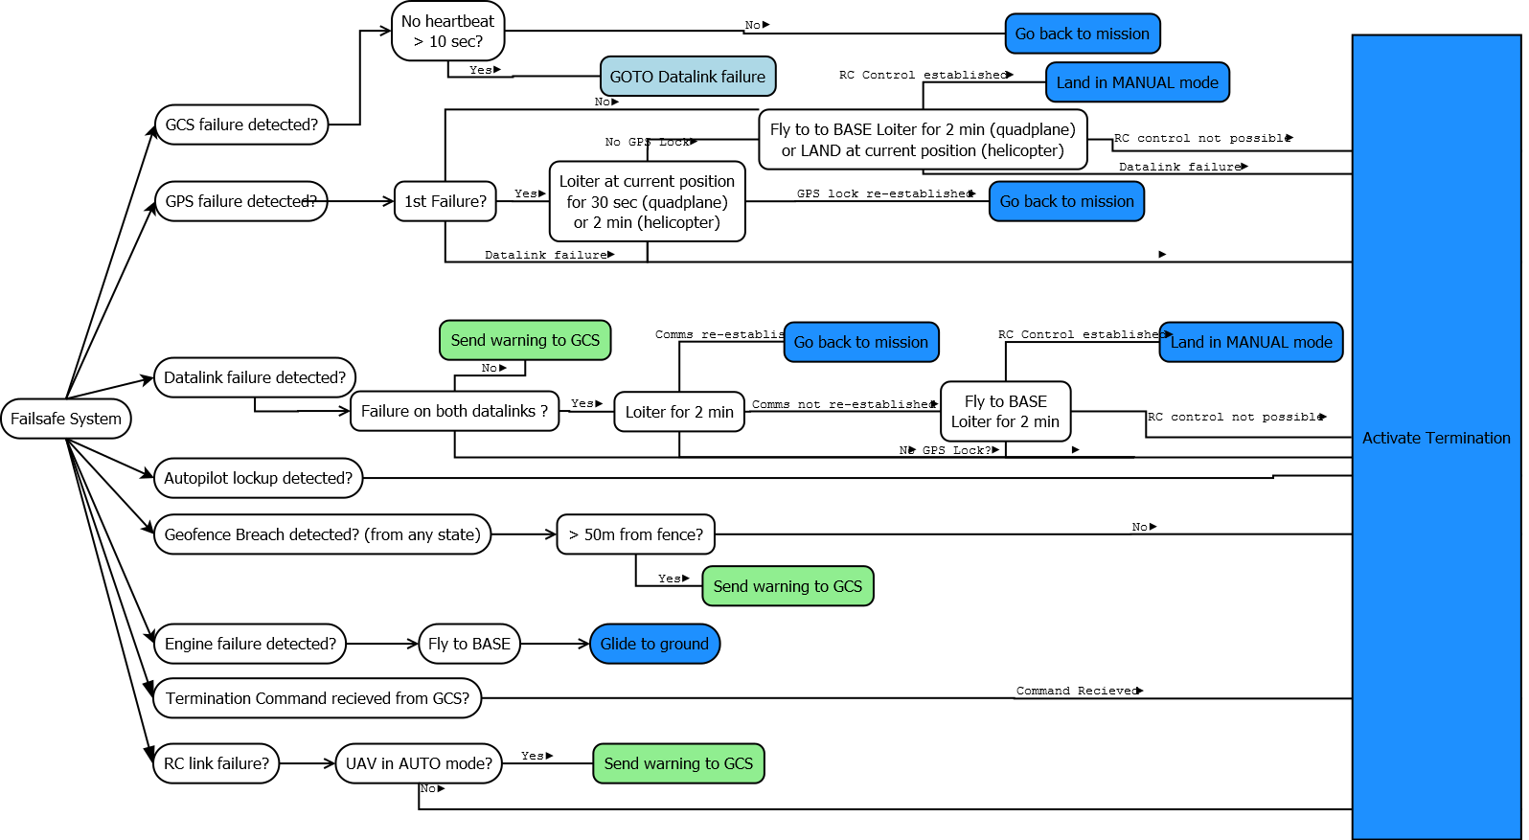

Figure 3 - Failsafe State Diagram

## Flight Termination Method Analysis

The flight termination method will be in accordance with Section 9.1 of this report. The termination will be carried out by an independent CPU on the Pixhawk flight controller, which has exclusive access to the servo and ESC signal lines. Based on ground testing, the control surfaces go to failsafe positions in less than 1 second after the command being issued by the ground control station.

For the helicopter airframe activation of termination will immediately cut ignition and throttle to the engine. The aircraft will enter an emergency descent state, holding its current position. We estimate that from an initial cruise speed of 58 knots and altitude of 400 feet the UAV will impact the ground within 30 meters from the point that termination was activated.

For the quadplane airframe activation of termination will cut power to the vertical lift motors and set all fixed wing control surfaces to maximum deflection. Ignition to the IC engine will be cut, and throttle set to zero. Simulation testing indicates that for a geofence breach at cruise airspeed of 56 knots at an altitude of 400 feet the aircraft will impact the ground within 200 meters of the point that termination was activated. This assumes worst case wind conditions of a 25 knot tail wind.

Out of the scenarios listed above, the maximum either UAV could travel past the geofence in a worst-case scenario is 200m.

## Geofence system design

If the autopilot detects a mission boundary violation (either horizontal or vertical) it will raise a signal on the C&TS, which will initiate flight termination. Mission boundary edges and altitude limits will be programmed into the autopilot’s non-volatile memory and checked during pre-flight prep.

This system has been verified to work through extensive simulation and real world testing with prototype airframes. The CanberraUAV geofencing system has been adopted as a standard feature in the APM software suite.

Any lockup or failure of this function on the CPU or associated sensors will be treated as an Autopilot lock-up (Section 9.5) and will result in the C&TS system being activated.

A “soft geofence” will be used to alert the ground station via audible signal when the aircraft's current course is predicted to take it within 50m of the actual geofence. For the vertical component, a dataset of terrain data for the local area will be available to the aircraft. Combined with the GPS altitude, the AGL altitude can be determined and used to ensure the aircraft remains in the altitude (AGL) envelope as a “soft geofence”.

### Altitude Geofence

The barometer on board will be referenced via QNH before flight. This will be used to enforce the 1500 ft AGL vertical component of the geofence.

On barometer failure, the autopilot will start to use GPS based altitude but with a safety margin of 500ft. If the GPS loses lock or detects an altitude of above 1000 ft AGL the C&TS system will be activated.

## Radio Equipment

There will be three independent radio links to each UAV. This includes a standard 2.4 GHz RC link for manual control, a 915-928 MHz low bandwidth link for telemetry and a 3G mobile phone network connections (via USB dongles) for a backup telemetry links. Constant communication with the UAVs will be maintained through these redundant links. Failover between the links is handled automatically by the APM and ground station software.

The relay aircraft 915-928 MHz telemetry radio will be setup both as a relay for messages between the GCS and retrieval aircraft and as a telemetry link for the relay aircraft.

The 915-928 MHz is licenced under the ACMA LIPD class licence (Item 52) and the 3G dongles will use the standard 3G frequency bands (850MHz, 900MHz and 2100 MHz). All radios used will be “C-Tick” compliant.

The telemetry link has been confirmed to consistently work at 30km range via the relay UAV at the desired data rate.

# Risk Assessment

## General Risk Assessment

Using the risk assessment in our Deliverable 1 report as a basis, we expanded on and refined our risk assessment to ensure it remains up-to-date.

| **Failure Mode** | **Mitigation** |
| --- | --- |
| Insurance | * Preliminary work will be carried out at our local model aircraft field under MAAA procedures with MAAA insurance, and the regular critique of fellow modellers. Extensive testing will be carried out at a private property near Canberra, within the one year span of appropriate insurance. |
| Airframe Operation | * Operation to be in line with MAAA procedures. * Competition aircraft and pilots will obtain MAAA heavy model certificate before flight of competition aircraft, if required. |
| Airframe Modifications | * Any modifications to the physical airframe are to be reviewed by experienced RC modellers to ensure structural integrity is maintained. * Flight envelope (such as maximum roll angle, maximum speed, etc) will be limited reduce stress on airframe modifications. |
| Range Safety | * For the MAAA field we will use the MAAA Manual of Procedures. For our long range test site, we have developed appropriate range procedures, with a designated range safety officer. * We have developed a safety bag so that all the items we need for safety purposes are handy during operations. |
| Engine | * Starting and operation to be in line with MAAA procedures. * The engine can be stopped by cutting the ignition via the safety switch, the RC transmitter, or the ground control system. |
| Vertical lift motors | * The motors are mounted on each wing with their LiPo batteries. * They must be specifically armed to operate. * The batteries are independent of the aircraft control systems, and require connection via relays to power the motors. * There will be some padding and a layer of fireproof material around the batteries. |
| Fuel | * Petrol will be contained in a strong container to resist bursting on impact, containing only enough fuel to carry out the mission with adequate reserve. Appropriate safety procedures will be implemented for transport and storage. |
| Electrical power | * Separate battery packs for instrumentation and C&TS. * Batteries in the helicopter will be placed within a strong purpose-made battery compartment. * Batteries to be of capacity adequate for mission with reserve. * The E-stop will be used to isolate battery power from radios and motors when UAV is not in flight. |
| Connections, wiring and soldering | * To be carried out by experienced electronics technician with years of experience in model aircraft and marine electronics in the field. |
| Autopilot | * Loss of the Autopilot's heartbeat will be detected by the C&TS and appropriate actions taken. |
| Geofencing system failure | * Failure of the system running the geofencing program will alert the C&TS by loss of the heartbeat. |
| Fly away of UAV | * Extensive practice at test range to UAV Challenge rules (including geo-fencing), but with a soft termination to be carried out by the C&TS. * Low energy VTOL takeoffs will be employed to enable long reaction times. |
| Rescue of lost UAV | * Procedures to be put in place by our experienced bushwalker prior to field testing. |
| Bugs in software | * Will use Software In The Loop (SITL) simulation testing to verify software and autopilot hardware, and reduce risk of software bugs. * We have a range of smaller test aircraft and helicopters on which we test our software and practice our procedures. |
| Configuration management | * We are using best software industry practice for configuration management and software version control. |
| Fatigue/illness of personnel | * Fatigue and readiness to participate are actively managed during our activities. * Team members participating on the site able to perform the role of another if required. |
| Damage to blood sample on return journey | * Blood sample container will be padded and placed away from heat sources. |

## Risks Associated With Autonomous Takeoff and Landing

In the specific cases of autonomous takeoff and landing, the following risk assessment has been generated:

| **Failure Mode** | **Mitigation** |
| --- | --- |
| High wind conditions | * Airframes will be tested in a variety of wind conditions to give a maximum safe wind speed for operation. |
| Uneven ground at landing site | * The undercarriage will be designed to cope with landing in rough terrain * The roll and pitch of the UAV will be checked after landing to ensure the UAV is not leaning at a dangerous angle and thus is unable to safely take off. |
| Obstacles at landing site | * On-board camera will take high resolution photos of landing site, which will be analysed by ground station personnel before landing. |
| Unseen damage to airframe during landing | * After landing, systems will be checked for abnormal readings via telemetry. Takeoff will be aborted if telemetry indicates damage to flight controller, radio or battery systems. |
| Airframe safety to nearby people after landing | * UAV will disarm all propulsion motors and engines upon landing. |

# Risk Management

Managing the safety of people, property and the aircraft is at the forefront of all of our design and testing activities. We manage and reduce overall risk by ensuring we have redundancy in all mission critical systems, the use of on-board failsafe systems and thorough ground testing and checklist procedures before flight.

In designing our system, we started by building a risk management matrix, identifying possible modes of failure and evaluated risk mitigation measures. This risk management matrix considered the consequence and likelihood of potential hardware and software failures.

The following section will outline our risk management approach for key items as outlined in the requirements for Deliverable 2.

## Flight Termination

We are using a control and termination system (C&TS) on board the Pixhawk’s secondary processor. This module, although on the same physical board as the autopilot, is completely independent. The necessary software development has been completed, tested and incorporated into our baseline flight management system.

This system was confirmed as meeting the Outback Challenge failsafe requirements in an email from the UAV Outback Challenge Technical Committee on March 6th 2014.

The C&TS will implement the primary OBC S&R FTS option for the quadplane using fixed maximum servo positions and zero motor power. For the helicopter, termination is implemented by cutting ignition. The C&TS will monitor the autopilot and will control flight surface, ESC and throttle servos, following the specific procedures outlined in the following sections. Flight termination can also be initiated by the GCS through controls to the autopilot via the redundant telemetry links.

In case of flight termination activation, the servo and ESC positions for the quadplane will be forced by the C&TS system to be:

* Throttle closed
* Full up elevator
* Full right rudder
* Full down on the right aileron and full up on the left aileron
* Zero throttle on vertical lift motors
* Ignition cut on the IC engine

If the flight termination mode is activated by any of the conditions described in Sections 9.2-9.6 it cannot be deactivated.

## Loss of data link

The on-board mission computer monitors data link integrity via MAVLink heartbeat messages sent from the GCS at a rate of 2Hz. On loss of data link for 10 seconds, the UAV will loiter at its current position. If data link is not re-established within 2 minutes, the UAV will then fly back to Base and loiter for 2 minutes. During this time the safety pilot will attempt control via visual line of sight. If line of sight RC control is not possible flight termination will be initiated. If RC control is possible the safety pilot will land the UAV. Flight outside the mission boundary at any time will cause flight termination including during a loss of data link.

For the specific case of the retrieval aircraft losing data link during the landing descent at the remote site the automated landing will continue. The aircraft will not allow for takeoff and continuation of the mission unless the data link is regained.

## Engine Failure

The aircraft will have electronic engine monitoring. In case of engine or ignition failure, the UAV will initiate a controlled glide or autorotation (with the ignition off) towards the base waypoint. If the aircraft achieves visual range of the airfield the safety pilot will be able to control the glide via the standard RC transmitter link. If visual range of the safety pilot is not achieved the plane will land as best it can within the mission boundary. All other failsafe systems remain active during this procedure and will initiate a full flight termination if needed.

In the case of the quadplane, the vertical lift motors can be used to safely land the UAV in case of failure of the IC engine. The vertical lift motors will be arranged in such a way (such as an X8 configuration, for example) that a single vertical lift motor failure can be compensated by the remaining motors.

## Loss of GPS Position

In Loss of GPS Position mode the quadplane will slowly circle for 30 seconds, waiting for GPS signal. If there is no signal after 30 seconds then the autopilot will start dead-reckoning to the base waypoint via the Transit Corridor. During dead reckoning the on-board sensors will be used to monitor the UAV’s status. If the UAV’s position within the mission boundary becomes uncertain or the link to GCS is lost during a period of GPS failure then flight termination will be initiated.

On a second Loss of GPS Position, the quadplane will dead-reckon to the base waypoint (via the transit corridor) and loiter for 2 minutes to allow a manual landing by the pilot. If this is not possible then flight termination will be activated. If the planes position within the mission boundary becomes uncertain or the link to GCS is lost during a period of GPS failure then flight termination will be initiated.

Unless under manual control by the safety pilot, loss of data link while in Loss of GPS Position mode will cause an immediate flight termination.

For the helicopter Loss of GPS Position mode will cause a position hold for two minutes. If GPS position is not regained after two minutes the helicopter will land immediately at its current position. Due to the unreliability of dead-reckoning on rotary wing aircraft dead-reckoning will not be attempted for the helicopter.

## Autopilot lock-up

The autopilot will provide a 10 Hz heartbeat signals to the C&TS system via a dedicated high-speed serial line. If the autopilot fails to provide a heartbeat for a period of 1 second, the flight will be terminated by the C&TS system.

## Failure of Ground Control Station

If an autopilot detects no communications heartbeat signal from the GCS for a period of 10 seconds then the loss of data link procedure described above will be initiated. Note that in our design the ground station has multiple communication links (on different frequencies) to the aircraft and is able to automatically switch between the links to minimise the chance of link loss.

## Li-Po Battery and Fuel Management

Fuel will be stored in AS/NZS 2906:2001 standard jerry cans when not required for UAV operations. The UAV will only be fuelled shortly before a mission and will only contain an appropriate amount of fuel to complete the mission, with some reserve.

Li-Po batteries will be stored in fireproof containers when not in use. These boxes will be stored away from flammable or combustible objects at all times. Battery recharging will be performed away from flammable or combustible materials. In all cases a fire extinguisher will be nearby in case of emergency

The battery condition and voltage will be checked before and after recharging and before use in a UAV flight. Any batteries showing bad voltages or showing signs of puffing will be marked as “not good” and will not be used.

## Other risks identified in risk management section

### Bugs in Software

All aircraft software and hardware is thoroughly tested before being used in flight. The testing regime includes simulation where possible and small scale testing before being used in the final aircraft.

Our testing methodology is:

* Design and build new component or feature
* Software simulation testing where possible
* Hardware simulation testing where possible
* Short and long range test flights
* Acceptance

We make extensive use of additional test airframes for testing new features.

### Range Safety

Short range tests are performed at Canberra Model Aircraft Club (CMAC), where we follow all MAAA and CMAC rules and procedures.

We have developed a range safety plan for use at our long distance testing facility. The focus of this plan is on physical safety and on ensuring that personnel have defined roles and responsibilities. This includes the position of “safety officer” who will oversee the day's flying activities and ensure that all procedures are followed.

# Flight Test Results and Discussion

## Project Status

As of March 2016, CanberraUAV has achieved the following:

* Successfully trialled the Pixhawk flight controller as an autonomous helicopter flight controller
* Developed the APM software to support quadplanes
* Built and tested a number of small and large quadplane and helicopter airframes
* Successfully trialled electric staters for IC engines

## Results

### Test Flights

CanberraUAV has built up a small fleet of helicopters and quadplanes of various sizes in order to assist with our development.

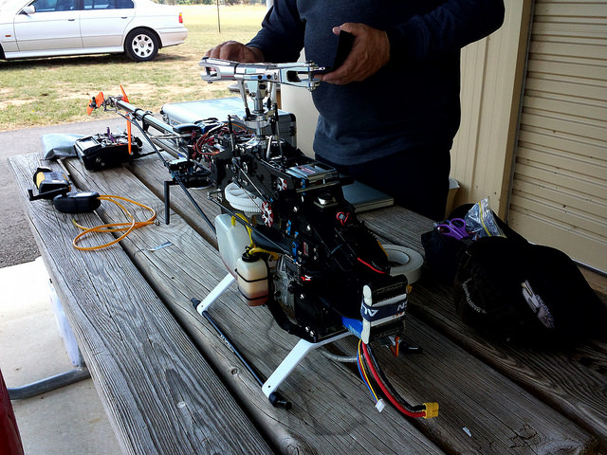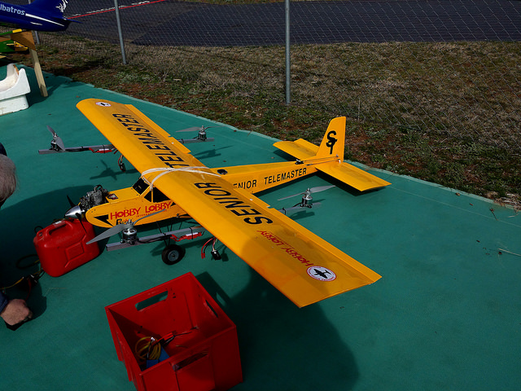

Figure 4 - Two of our test airframes. The quadplane Telemaster (L) and Trex-700 helicopter (R).

These test flights have allowed us to refine both the hardware and software required to control vertical takeoff and landing airframes.

The hardware part has consisted of evaluating different airframes for their suitability in carrying out a long-range mission and being able to remotely start their engines. In the case of the quadplane, we have gone through many iterations of vertical lift systems in order to have enough power to safely lift the fixed-wing airframe whilst not requiring excessive numbers of batteries or complicated electrical systems.

The software (APM:Plane) has been greatly enhanced to support quadplanes with automatic transition between horizontal and vertical flight modes. The APM:Copter software (used on the helicopters) has been further refined to be more reliable and accurate in large helicopter airframes.

We have researched and tested many different electrical power systems to develop a system capable of handling the high current spikes caused by the manipulation of the helicopter's main rotors at a high response rate. The power supplies were tested for their ability to supply large amounts of transient current with a minimal response time whilst maintaining the required voltage.

In terms of helicopter control, a flybarless (FBL) gyro was fitted between the Pixhawk and collective servos in order to allow safe manual control of the helicopter. To do this, the APM software on the Pixhawk was altered to output the standard 4-channel AETR (aileron, elevator, throttle and rudder) values over PWM which would then be converted into values for the collective and tail rotor. With safe manual control available at all times, helicopter development is both safer and faster.

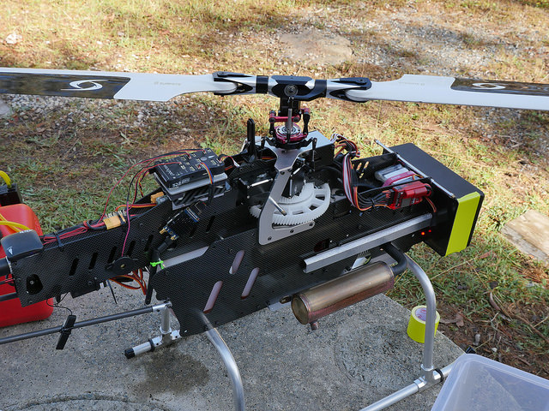

Figure 5 – The Gaui GX9 with Pixawk and FBL rate controller

This has all been combined with lots of test flights! We have several workhorse test aircraft that we use to test out the new systems as we develop them - logging dozens of hours of test fights, and spending countless hours analysing logs to ensure that the systems we develop work as expected.

We hope that all of our work will result in us putting in a good showing at the 2016 Medical Express, although of course we realise that things can go wrong on the day!

# Conclusions

By using a design approach based upon safety and reliability and learning from our experiences at the 2012 and 2014 Outback Challenges, we are well on our way to presenting a more mature, more effective and more reliable system for the 2016 UAV Challenge.

At this point in time, all of our airframes have been tested, with developmental testing broadly complete. Our operational test and evaluation program is progressing smoothly and we plan to run as many flight tests as practical before October 2016.

We are very pleased with our results so far andthrough the continued hard work of our team members, we are on track to have a capable and reliable system well before the competition deadline.

The next challenge for us is to integrate our long range telemetry and camera systems, which are incremental improvements on the reliable systems have developed and used over the past 5 years.

We are looking forward to meeting the other teams in September and competing in the 2016 Medical Express!